**Io’s Atomic Airglow in Jupiter’s Shadow**

**Carl Schmidt, Nick Schneider, Lorenz Roth, Katherine de Kleer, Mikhail Sharov, Cameron Moye, Denis Grodent, Imke de Pater, Phil Phipps, Al Conrad, Klaus Strassmeier, Ilya Ilyin, Christian Veillet, Luke Moore, John Spencer**

**Abstract:**

Using an optical echelle spectrograph at the Apache Point Observatory (APO) 3.5m telescope, we observe Io’s atomic emissions that are excited solely by electron impact or ion recombination while the moon is in full shadow. We observed these emissions falling rapidly in just several minutes following Io’s ingress, with sodium airglow declining more rapidly than oxygen. Although the atomic atmosphere is not in vapor pressure equilibrium like SO2, Na and O airglow drops with similar timescales to a decline in SO2 column density that Tsang et al. (2016) reported post-ingress. Interpretation of this behavior warrants care since airglow emissions depend both on photochemical pathways producing neutral atoms and on the plasma conditions: electron density and temperature.

While no new species are identified, several previously unreported emissions in atomic neutrals are observed in the far-red and near-infrared spectral range. Emissions here are hundreds of Rayleighs when averaged over Io’s disk and our measurements are insufficiently sensitive to record their temporal response to Io’s ingress. Co-added exposures reveal the potassium D doublet and a second doublet of neutral sodium near 8189Å. These spectra can finally explain the mechanisms for emissions seen in the Cassini’s near-infrared filters as it the passed near Io (Geissler et al. 2004), and bright spots near Io’s equator that the spacecraft imaged are reaffirm our assertion that Io’s near-IR emissions can trace energetic electrons. To the best of our knowledge, this is the first time that several of these emissions have been reported in a planetary atmosphere other than the Earth’s.

-First evidence of Potassium airglow, explains Cassini / Galileo ISS measurements in filters XXX

-Oxygen and sodium temporal behavior is decoupled.

-Atomic atmosphere shows little response to eclipse, contrary to previous findings. Emissions track plasma density.

**1.) Introduction:**

Sublimation support of Io’s sulfur dioxide atmosphere is very sensitive to small variations in its surface temperature. As Io passes into Jupiter’s shadow each orbit, its sublimation-supported atmosphere rapidly collapses, leaving volcanic outgassing as the primary mechanism sustaining Io’s thin atmosphere. -(Describe Tsang, 2016, de Pater et al. 2020)

-(Describe Geissler 1999)

-(Describe Bouchez 2001) Red line oxygen 6300Å and the sodium D doublet are Io’s brightest emissions at several kiloRayleighs (Bouchez et al. 2000).

-(Describe Geissler 2002, 2004)

The threshold energy for SO2 electron dissociative excitation of optical lines is 15–20 eV (Ajello et al., 1992a). The cross-sections increase to peak near 100 or 100s of eV, however, keV electron cross sections for exciting emission by impacts are far smaller. Laboratory experiments of electrons impacting SO2 efficiently produce O I triplets at 7774Å and 8446Å, as well as S I at 9225Å are at energy thresholds of 25eV or more (Ajello et al., 2008). Since this threshold is more energetic than the bulk ~5eV population within Io’s plasma torus, detection of these three triplets offers a new tracer for the superthermal plasma population local to the Io–torus interaction region.

-(Describe excitation types) dissociative excitation vs. recombination vs. electron impacts directly exciting the atoms. Difficult to disentangle these options. All the Cassini ISS wavelengths are dominated by the equatorial magnetic aligned spots, so emissions are at least co-located with high energy electrons. We haven't tried Chianti on Na and O line ratios yet, but that'll confirm if a high electron temperature is needed.

-(Must also mention Moore / Trafton, Oliversen 2001)

**2. Observations**

Geometries near quadrature between Jupiter, the Sun and Earth are necessary to observe Io in shadow while it is well separated from Jupiter’s bright limb. As the observation cannot be done near opposition, the eclipse campaign could not optimize against unwanted effects of airmass from the ground, nor geocorona from orbit. Table 1 lists the observations

Table 1. Optical wavelength measurements of Io surrounding eclipse

|  |  |  |  |  |
| --- | --- | --- | --- | --- |
| UT Date | Times | Telescope/Instrument | Orbital Longitudes | # of frames Sunlit/Penumbra/Umbra |
| 2012-01-04 | 9:37-10:22 | HST / COS | 15-21 | Time-tagged |
| 2012-01-11 | 10:58-11:41 | HST / COS | 10-16 | Time-tagged |
| 2018-03-201 | 10:33-11:24 | APO / ARCES | 349-356 | 6/1/6 |
| 2018-08-07 | 7:26-8:29 | Keck / HIRES | 359-8 | 0/0/10 |
| 2019-04-24 | 9:09-11:10 | LBT / PEPSI | 341-358 | 3/0/4 |
| 2019-04-29 | 16:21-18:26 | HST / COS | ?? | Time-tagged |
| 2019-08-12 | 4:56-6:27 | APO / ARCES | 0-13 | 4/1/10 |
| 2020-04-26 | 11:58-14:00 | HST / COS | ?? | Time-tagged |
| 2020-10-01 | 3:04-5:27 | APO / ARCES | 1-21 | 7/1/8 |
| 2020-10-17 | 2:01-2:52 | APO / ARCES | 7-14 | 4/2/2 |

**1Concurrent with ALMA molecular observations (see de Pater et al. 2020)**

**2.1 Far Ultraviolet Spectra**

Four observations of Io used the G130M grating of the Cosmic Origins Spectrograph (COS), two surrounding egress in 2012 and two surrounding ingress in 2019-2020. The primary science aperture

**2.2 Optical Spectra**

Optical observations of Io in eclipse require precise timing and non-sidereal blind tracking to high accuracy. The accuracy of open-loop blind tracking can be confirmed by tracking sunlit satellites using the time-dependent non-sidereal rate. Blind pointing accuracy can be estimated in offsets to adjacent satellites. Optical spectra are still strongly contaminated by Jupiter’s scattered light even under optimal geometry. To mitigate this issue, Jupiter spectra are smoothed, aligned fit and subtracted from the eclipsed data. A residual airglow spectrum from the Earth and Io remain, which can be separated by Doppler shift. In regions where telluric absorption interferes with the data, such as O I 6300Å, telluric features are characterized and removed using blue fast rotator (BFR) and A0V stars. A Gaussian is then fit to Io’s line spread functions and integrated and give total brightness. Jupiter’s reflectance spectrum is also applied as a standard candle, and a correction is made for the fact that Io does not fill the slit aperture, so brightness’ reported here are effectively disk-averages.



Fig. 1 Diagram and guider frame images showing the ARCES aperture during ingress on 20 March, 2018.



Fig. 2 Io-Jupiter geometry during the LBT PEPSI measurement. Ask Mikhail, annotations not showing up in ghostview?

**2.2 Keck HIRES**

Like the LBT, offsets between a sunlit moons showed that Keck I’s pointing between the moons can be done with high precision. However, the tracking rates exhibited significant drift and so the observations re-aligned pointing to Ganymede between each exposure of Io-in-eclipse. The HIRES observations benefit from its long-slit capability, as opposed to the smaller PEPSI and ARCES apertures which are designed for point sources. A 7.0″ by 1.722″ slit obtained a resolving power of R~24,700. The long slit capability offers a much more robust subtraction of the strong jovian scattered light component. Io’s bright [O I] 6300Å red line emission was used to find Io’s location along the slit, and the sky was interpolated from sampling on each side. The highest source of noise in the residual spectrum is due to the imperfect flat fielding correction of the silicon fringing pattern >7000Å.

**3. Optical Airglow:**

**3.1 Oxygen:**

5577A **e**lectron impact: 4.19 eV threshold. The lifetime of the electric quadrupole transition is 0.794s. From SO2: From threshold to 400 eV electrons upon SO2, Kedzierski et al. [2000] measured the electron excitation cross section of atomic O metastable fragments in the 1S state at 150 eV to be 2.2 × 10−18 cm2 Can't read this article:Candian Journal of Physics. But, citing Ajello et al. (2002)'s citation of the paper: " 2.0 x 1018 cm2 at 100 eV" and "The O 1S cross section falls rapidly with decreasing energy, attaining a value of about 5 x 10-19 cm2 near 20 eV."

In sunlight the, disk integrated 6300A brightness is typically 5-10 kR (Oliversen et al. 2001). They showed a correlation between the intensity and 6300A line width indicates molecular dissociation may contribute significantly. Local in the wake is ~20 kR, 1.97 eV is the minimum electron energy that can excite [OI] 6300 Å and/or 6364A. The lifetime from the magnetic dipole forbidden transition is 178s and 549s respectively, which is sufficiently long that eclipse response times may be smeared.

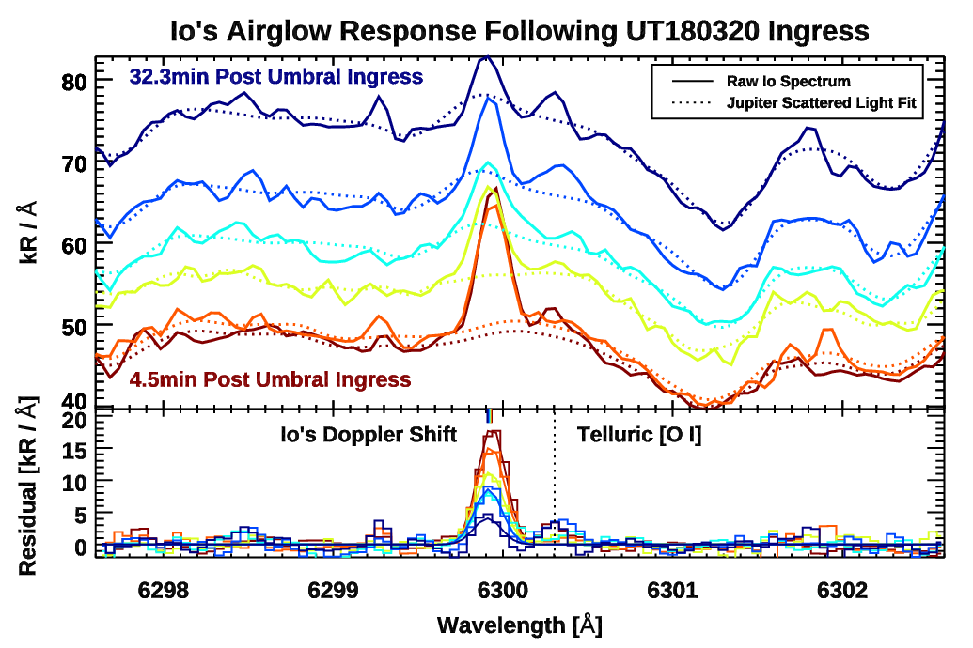 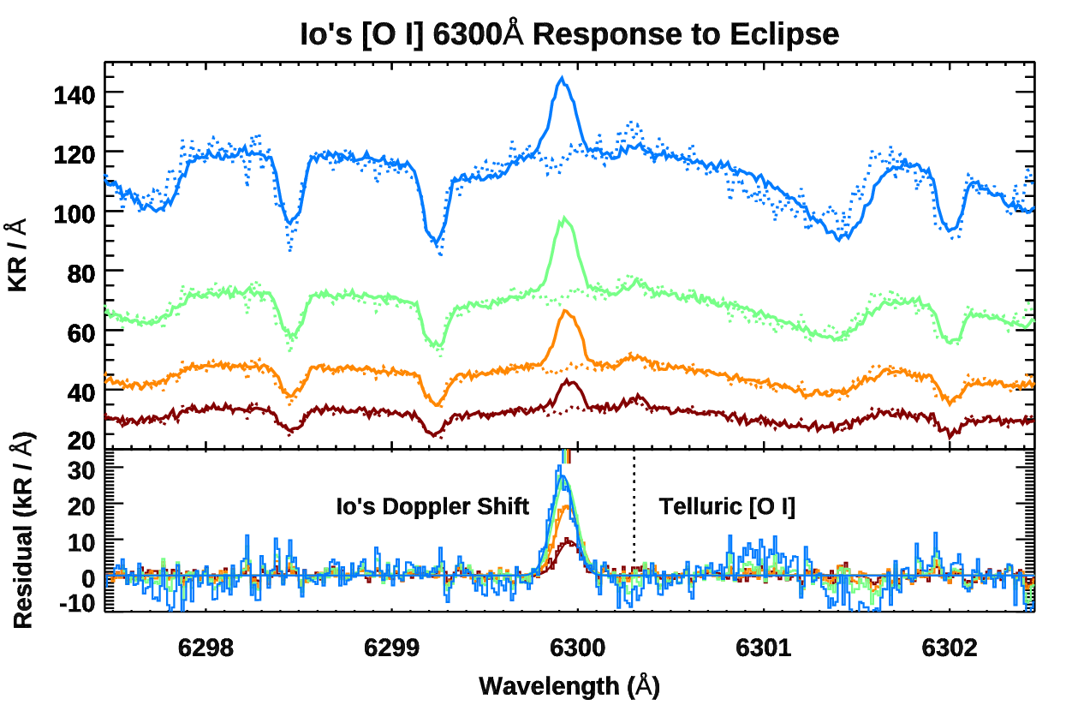

Figure 2. Io’s [O I] 6300Å line emission amidst Jupiter scattered light (top) and the residual of scattered light subtraction with a Gaussian fit in lower plot. Red to blue color scaling shows increasing time elapsed in shadow. As the moon’s position approaches the jovian limb, stray light levels increase. Re-name the LBT titles.

**3.2 Sodium:**

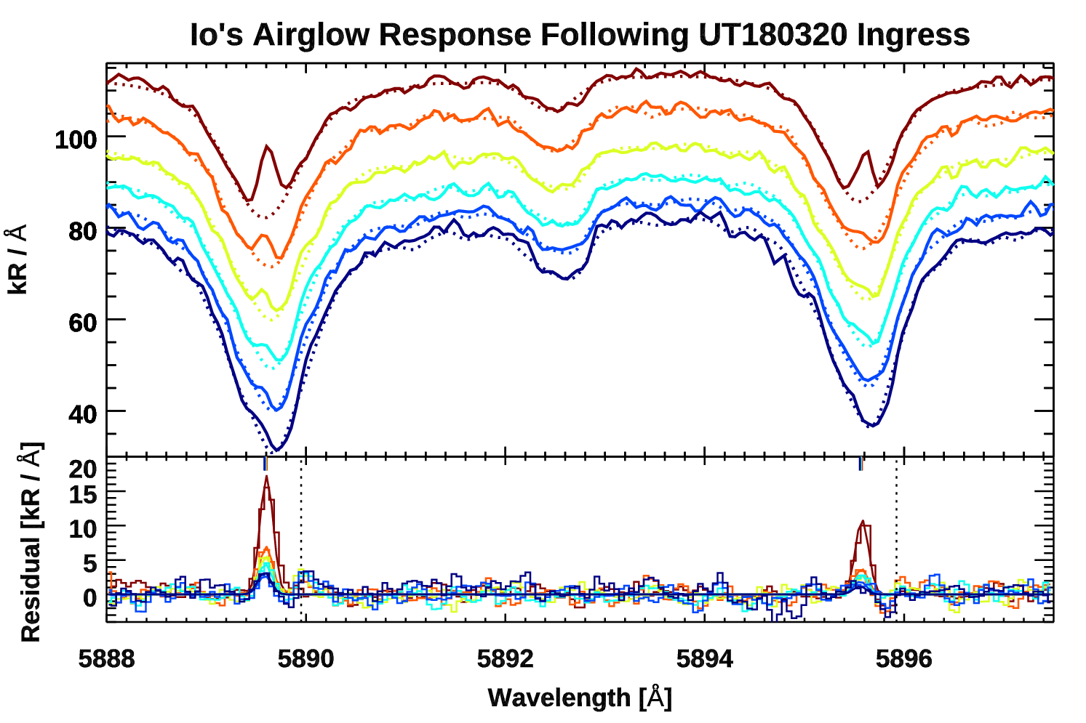 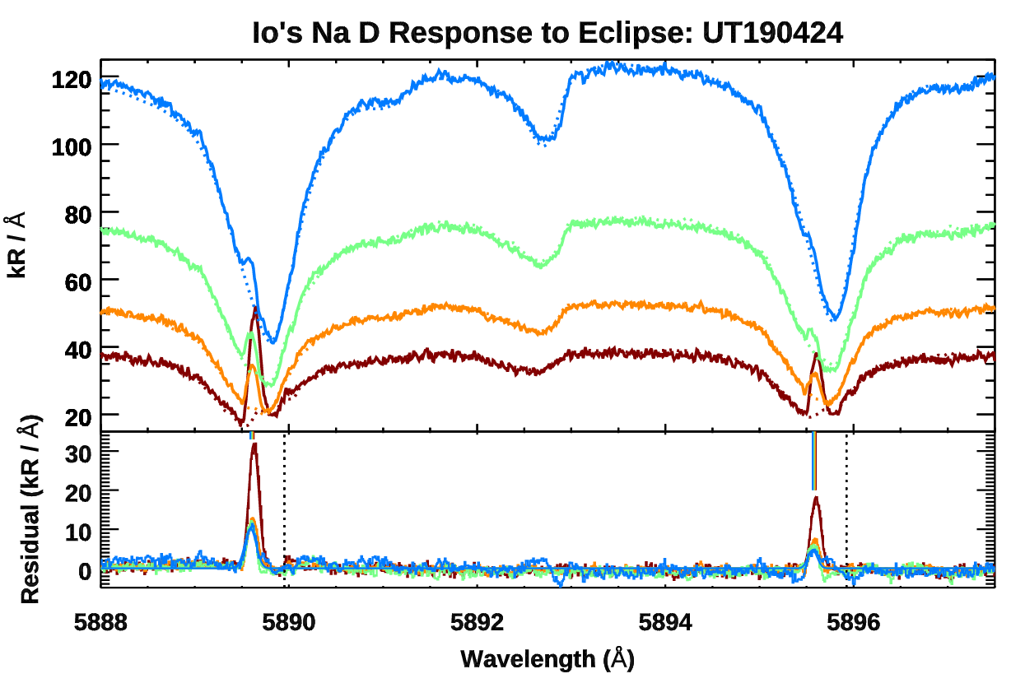

Figure 3. Spectra surrounding the Na D lines. Red to blue color scaling shows increasing time elapsed in shadow. In the upper panels, solid lines show raw Io spectra and dotted lines show fits to subtract the jovian scattered light background. Spectra in the top panels are consecutively offset by 12kR/Å for clarity. No offsets are applied to the blue spectra nearest the jovian limb. Name the titles. Change color scheme and offset LBT, parenthesis to brackets, APPLY offset

**3.3 Potassium:**

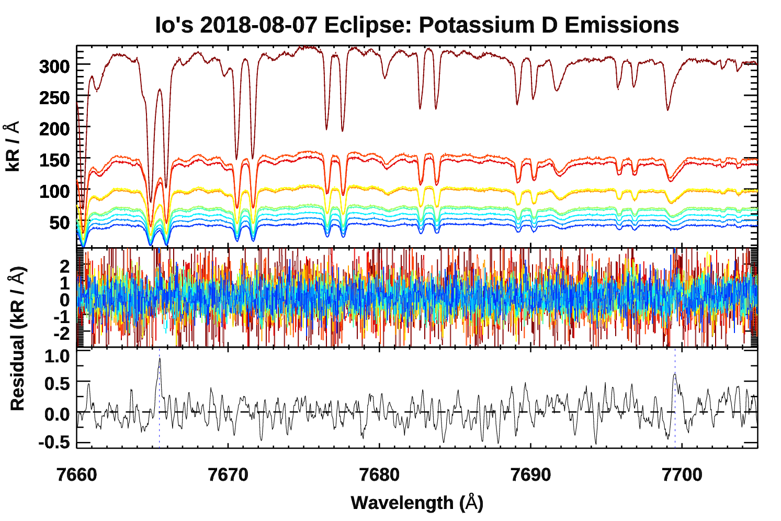

Fig. 4 Potassium D-line emissions seen prior to egress with HIRES on 2018-08-07. The bottom panel shows a median of 10 frames that have had telluric and jovian emission subtracted after co-aligning for Io’s changing Doppler shift. The stronger D2 line at 7665Å is partially absorbed by telluric O2, making the D2/D1 line ratio lower than the expected value of 2.0.

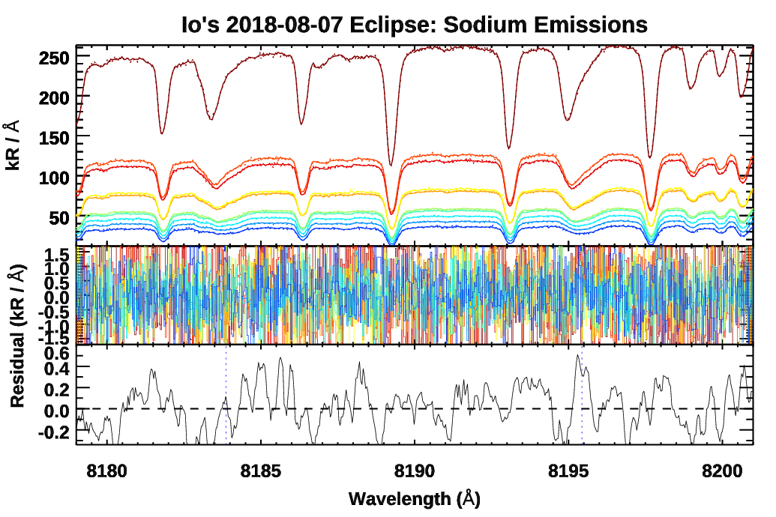

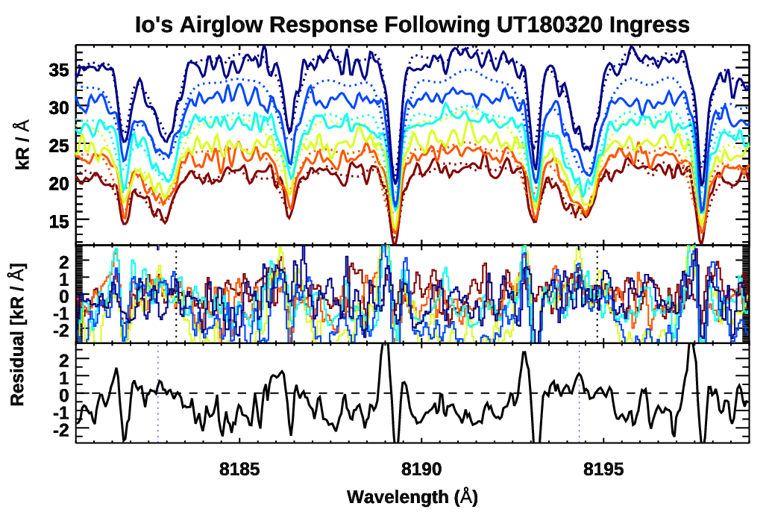

**7774A:**

2*s*22*p*3(4S°)3*p* into 2s22p3(4S°)3s, 5P to 5S°, J = 3,2,1 into J = 2. Transition energy 10.74 to 9.15 eV. 7774A triplet was by far the dominant emission line in the 380-800nm range for 50-225 keV electrons energetic protons hitting SO2 (Kiehling et al. 2001). Cross-section for SO2 + e- to produce the integrated triplet is 4.20 × 10−18 at 100 eV and 3.90 × 10−19 at 25 eV (Ajello et al. 2008). This produces the upper state of the 1356Å & 1358Å FUV lines (2p 3P–3s 5S).

**8446A:**

2*s*22*p*3(4S°)3*p* into *2s22p3(4S°)3s, 3P* to *3S°* J= 0,2,1 into J= 1. Transition energy 10.99 to 9.52 eV. Again, Ajello et al. (2008) has measured cross-section from SO2 + e- at 25 and 100 eV.

**9213, 9228, 9238A S I:**

3*s*23*p*3(4S°)4*p* into 3*s*23*p*3(4S°)4*s, 5P*to *5S°*,J = 3,2,1 into J = 2. Analogous to the 7774 O I multiplet. Transition energy 7.87 to 6.52 eV.

**4. UV Atomic emissions**

**Fig. 5 Here**

Fig. 5 Co-added emissions in all COS G/130M measurements of Io

Table 2 Here

Table 2. Line list of atomic and plasma emissions identified

**5. Temporal Behavior**

Fig X shows….In the case of the sodium D lines, the two emissions are added together. The values of the flux of the emission lines are then plotted against the time of each observation (6 total) and a clear trend appears for both. It is clear that immediately after Io enters the jovian umbra both Na D lines and O6300 sharply decrease. On the timescales permitted by this observation it remains unclear of the emissions have reached a new steady state associated with an atmosphere solely supported by volcanism.

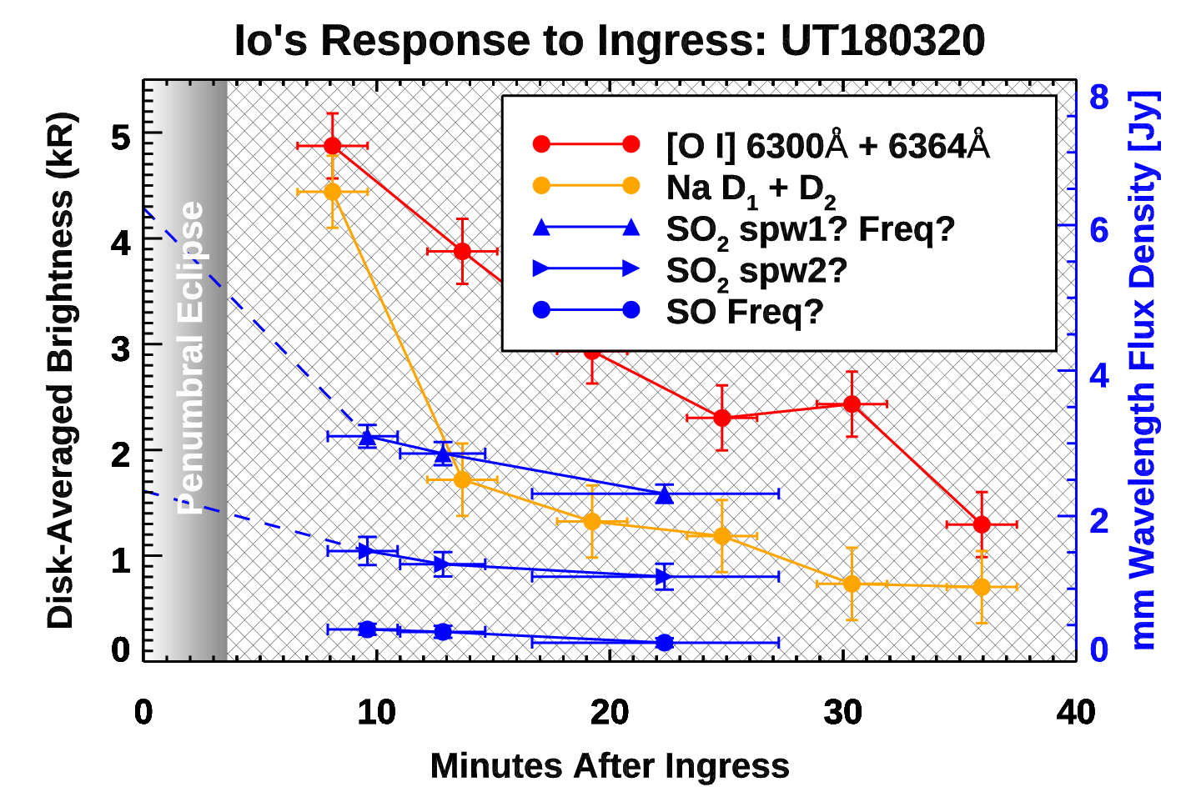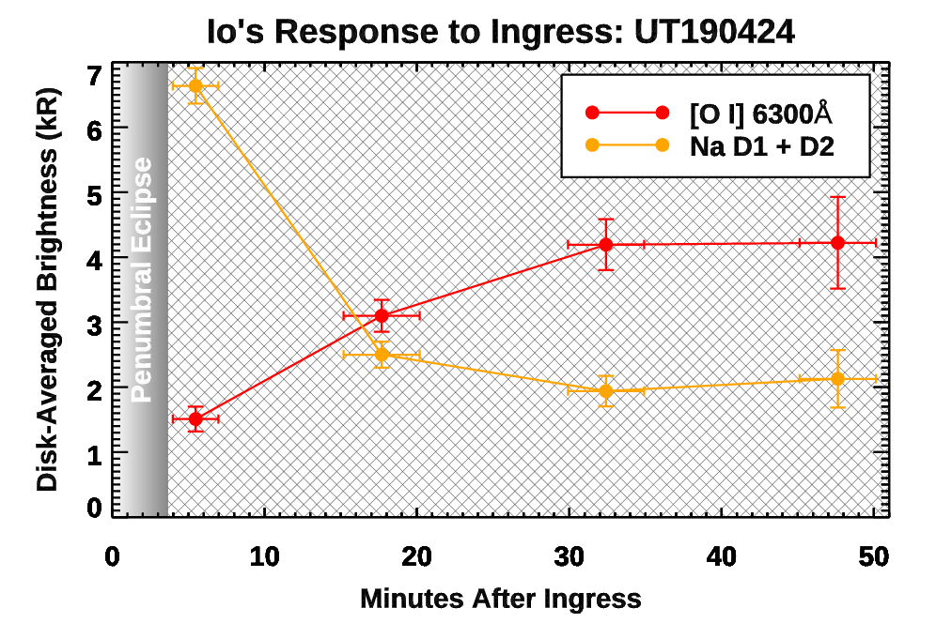

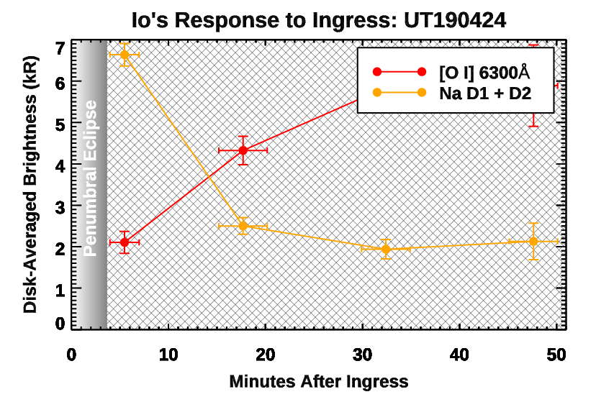

Fig. 6 Left: temporal response of oxygen and sodium emissions following ingress on 20 March 2018, alongside the molecular response reported by de Pater et al. (2020), shown in blue. Right: Response of during the 24 April 2019 ingress. Behavior of the [O I] emissions at 6300 & 6363 are dramatically different in each observation, while Sodium D airglow behaves similarly. **Finalize & check everything.**

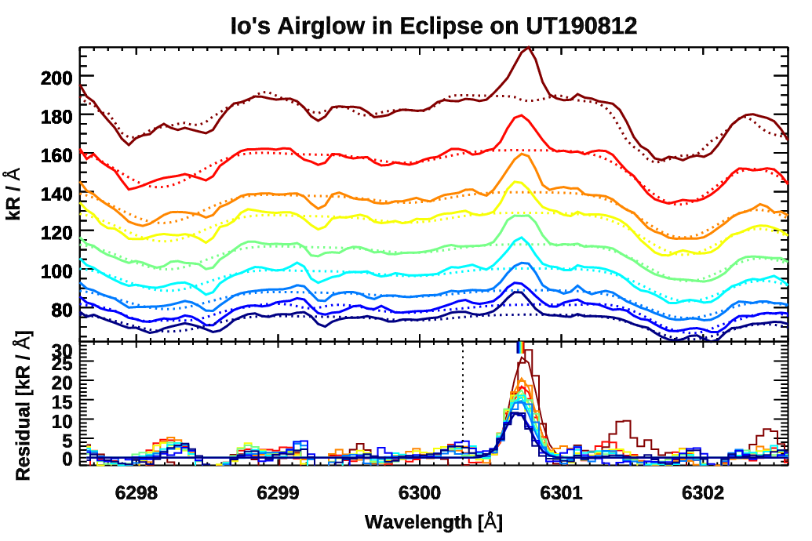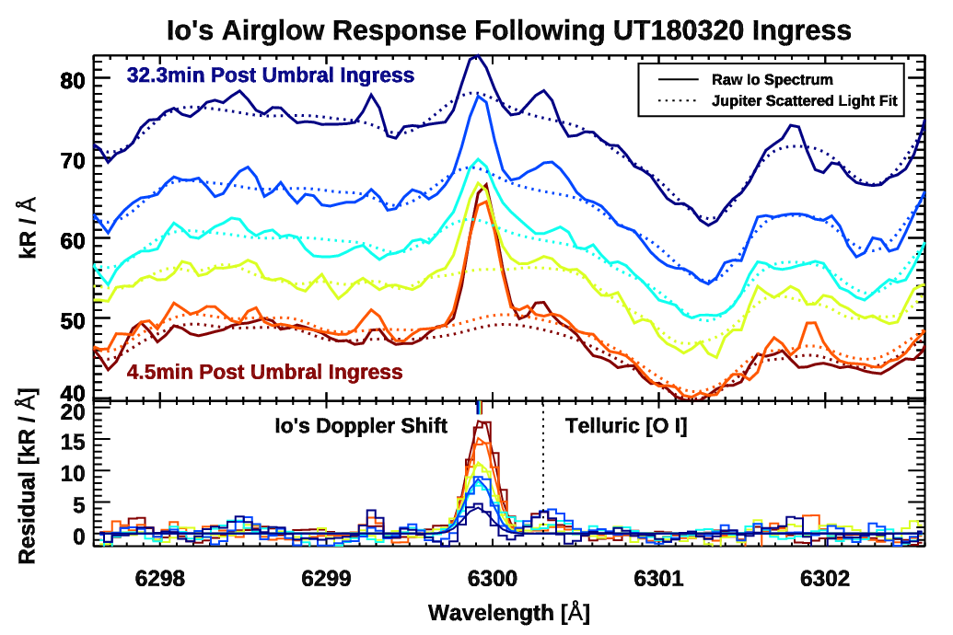

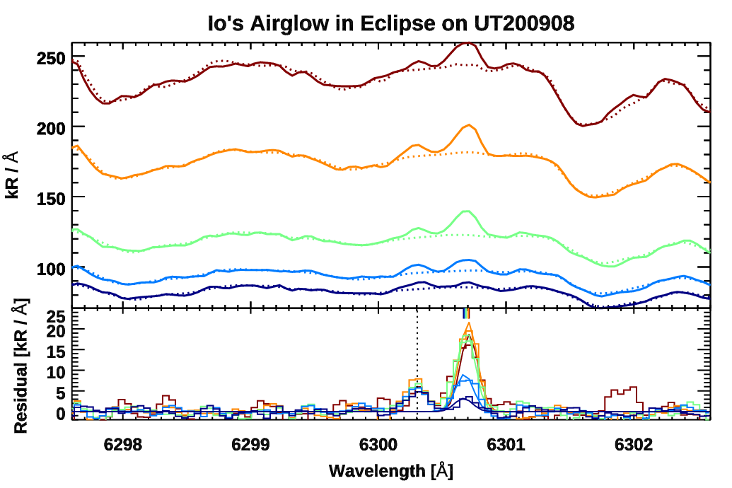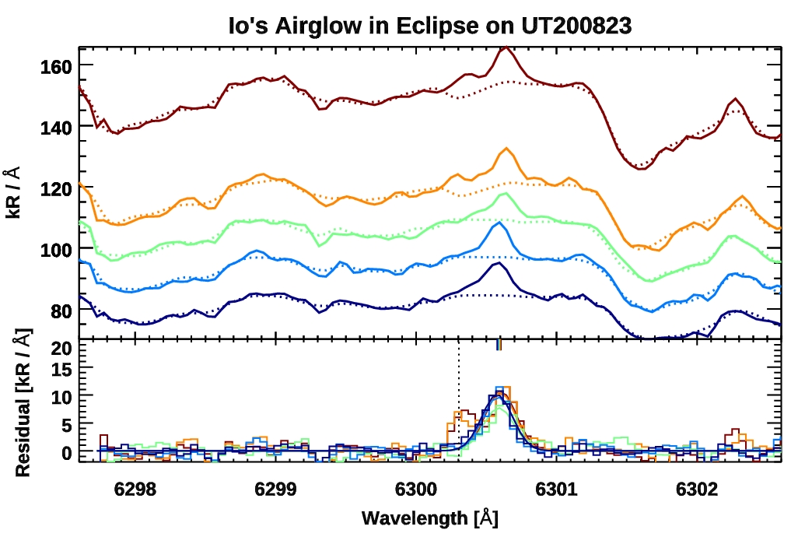

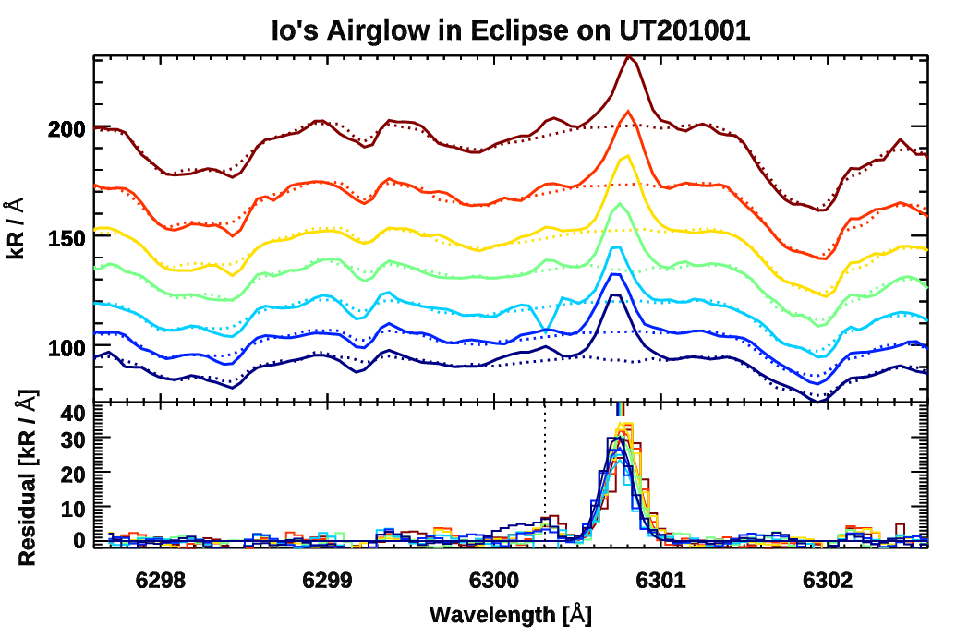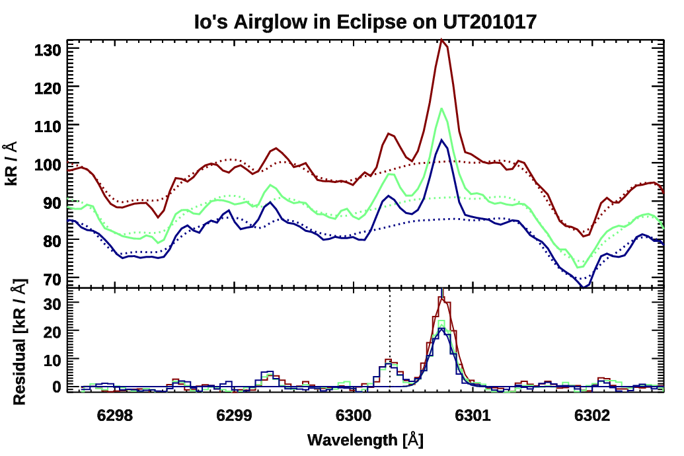

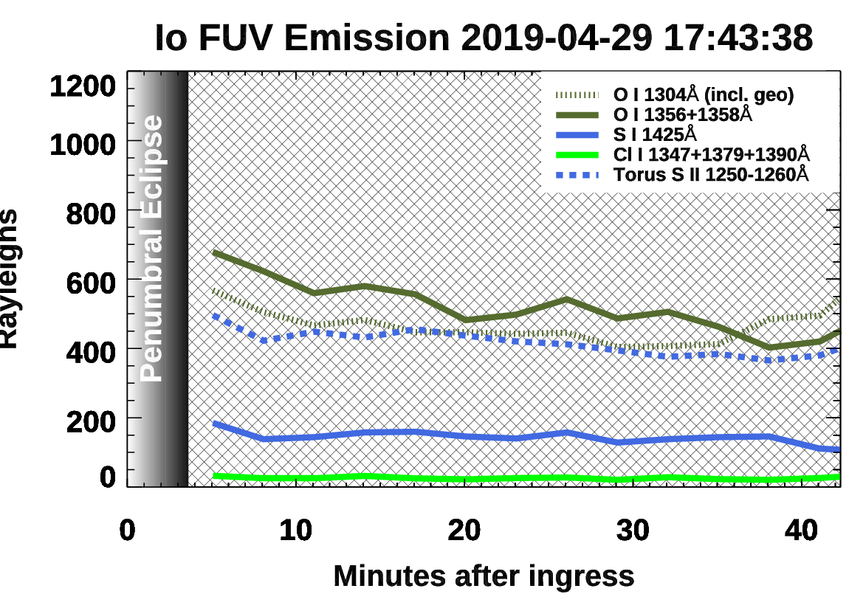

Fig. 7). Temporally binned behavior of the unblended FUV emissions surrounding ingress and egress

**5.1 Optical Depth Considerations:**

The Na D2/D1 ratio serves as a rough indicator of optical depth. In sunlight, D1+D2 integrated emissions are 41 kR, and the D2/D1 ratio of 1.65 ± 0.21 suggests an optically thick. Immediately following umbral ingress, electron excited D2/D1 measured 1.84 ± 0.12, while later emissions show the optically thin ratio of 2.0 within the uncertainty margins. The K D2/D1 ratio is uncertain since telluric O2 partially absorbs the D2 line.

Ratio 6300Å / 6364Å is 2.997 if optically thin. (Storey and Zeippen (2000) theory, Sharpee and Slanger (2006) measured nightglow)

FUV chlorine emissions exhibit little temporal variation. However, this behavior is a consequence of optical depth, which obscures our ability to probe the true column density of the atoms. The brightest emission at 1347Å

**Fig. 8 Here**

Fig. 8 Self-absorption in the Cl 1347 line profile.

**5.2 Correlations with torus latitude**

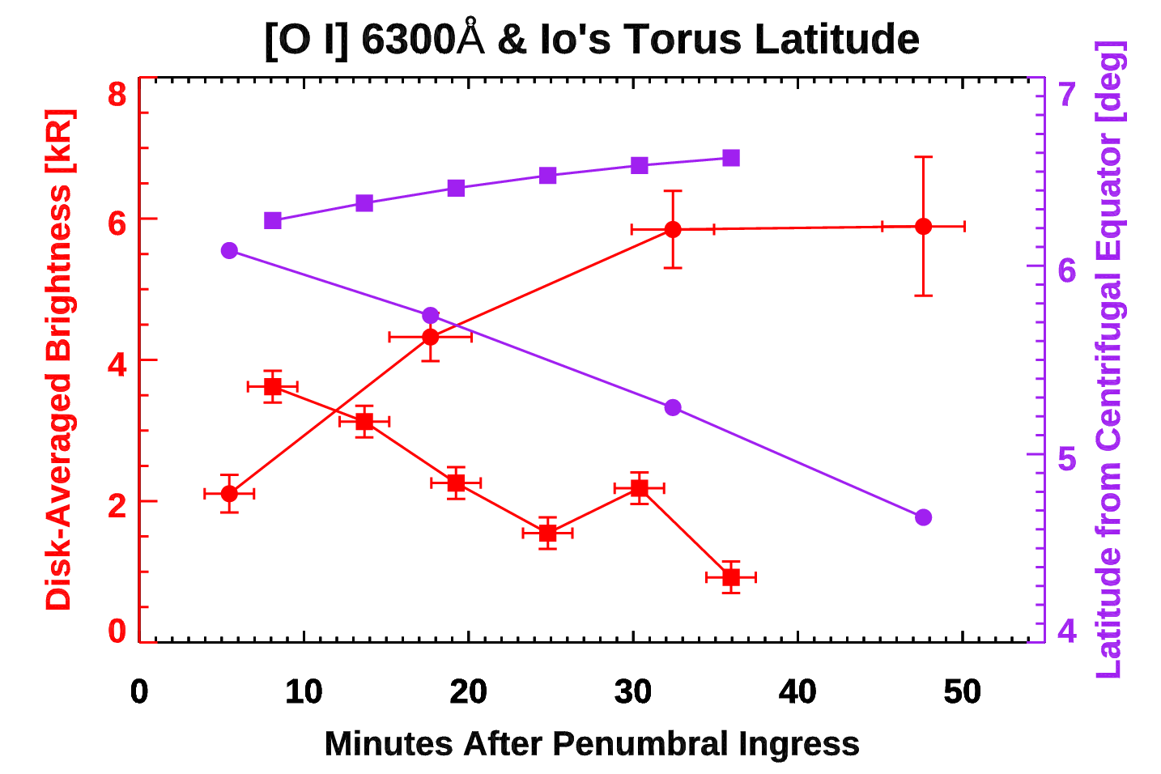

Fig. 9 Emissions as a function of Io’s latitude with respect to the centrifugal equator of the plasma torus. Change plot to brightness versus centrifugal latitude.

The torus is not symmetric in jovian local time and the densest region of the Io’s plasma torus termed the ribbon also exhibits radial wobble as a function of jovian longitude (Schmidt et al. 2018). Consequently radial variations ion the Io-torus separation should affect the emissions, in addition to latitudinal variations described.

**4. Near-IR Emissions.**

**7774A:**

2*s*22*p*3(4S°)3*p* into 2s22p3(4S°)3s, 5P to 5S°, J = 3,2,1 into J = 2. Transition energy 10.74 to 9.15 eV. 7774A triplet was by far the dominant emission line in the 380-800nm range for 50-225 keV electrons energetic protons hitting SO2 (Kiehling et al. 2001). Cross-section for SO2 + e- to produce the integrated triplet is 4.20 × 10−18 at 100 eV and 3.90 × 10−19 at 25 eV (Ajello et al. 2008). This produces the upper state of the 1356Å & 1358Å FUV lines (2p 3P–3s 5S).

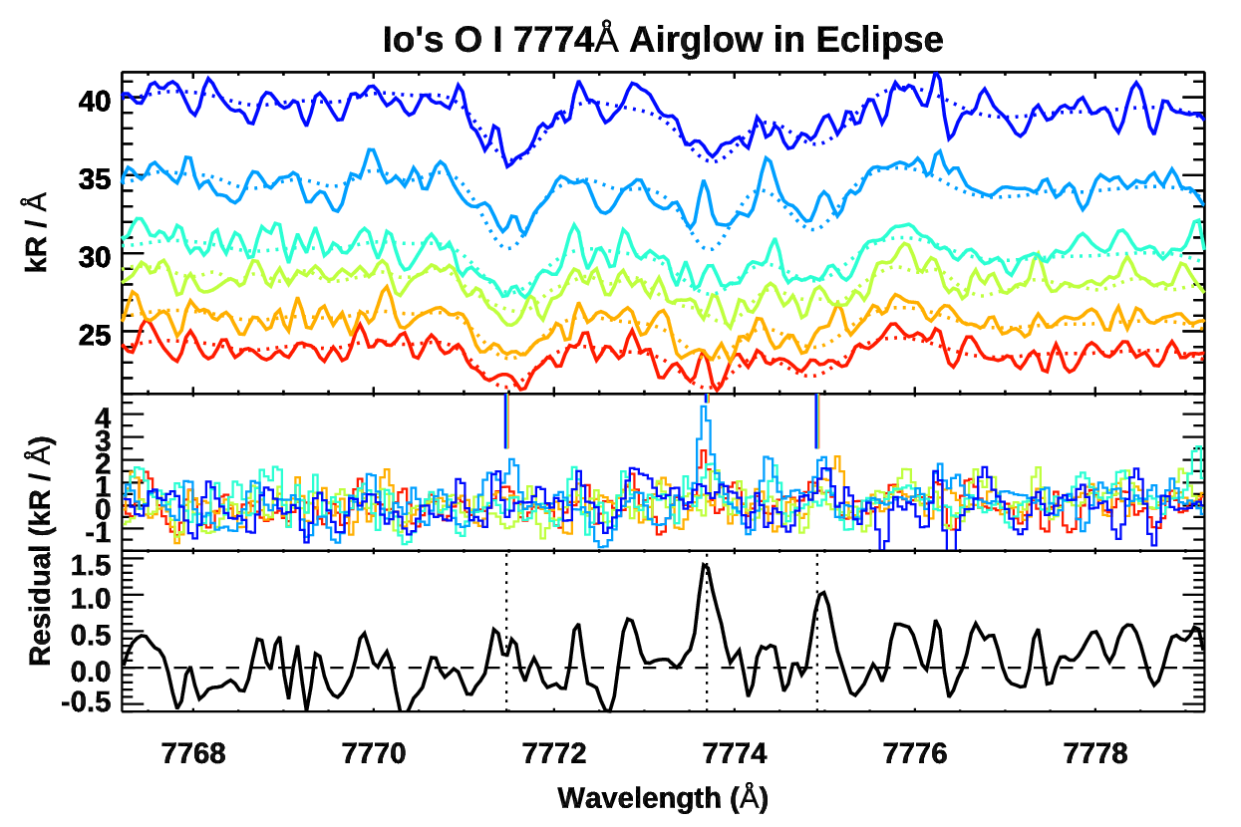

Fig. X: Fix Title, remove fits, separate average.

**8446A:**

2*s*22*p*3(4S°)3*p* into *2s22p3(4S°)3s, 3P* to *3S°* J = 0,2,1 into J = 1. Transition energy 10.99 to 9.52 eV. Again, Ajello et al. (2008) has measured cross-section from SO2 + e- at 25 and 100 eV.

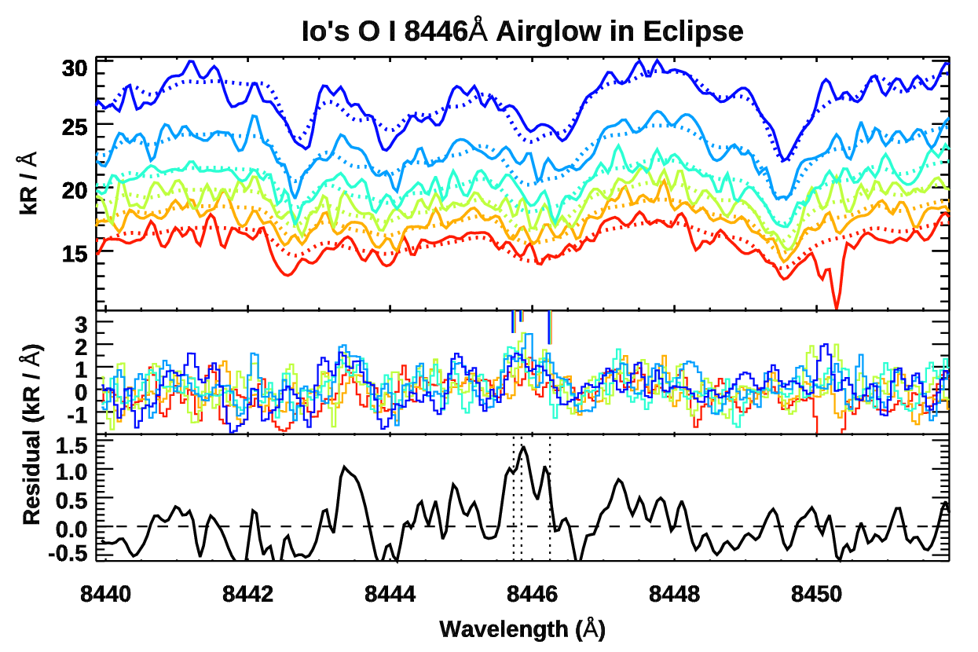

Fig. X: Fix Title, remove fits / indicies, separate average.

**9213, 9228, 9238A S I:**

3*s*23*p*3(4S°)4*p* into 3*s*23*p*3(4S°)4*s, 5P*to *5S°*,J = 3,2,1 into J = 2. Analogous to the 7774 O I multiplet. Transition energy 7.87 to 6.52 eV.

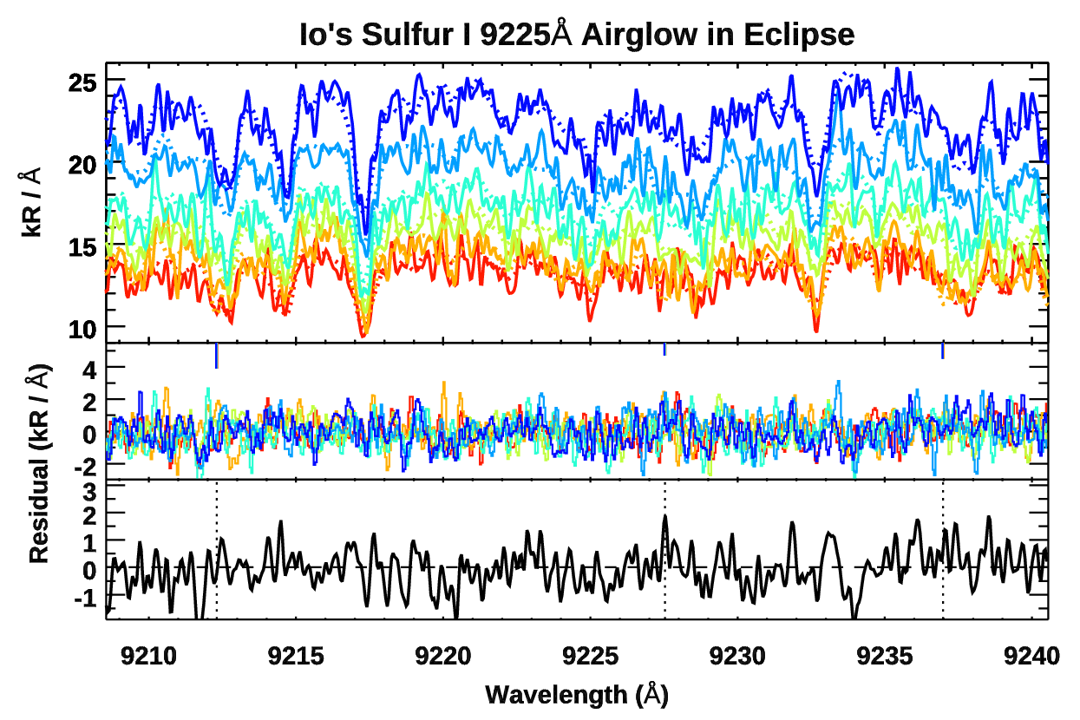

Fig. X: Fix Title, remove fits, separate average.

|  |  |  |  |
| --- | --- | --- | --- |
| **Line** | **Cross-section (e- energy)** | **Cross-section (e- energy)** | **Reference** |
| 5577 | 5 x 1019 (20 eV) | 2.0 x 1018 (100 eV), 2.2 × 10−18 (150 eV) | Kedzierski et al. (2000) |
| 6300.30, 6364 | ? | ? | Lifetime too long. Quenched in the lab. |
| 7771.94, 4.17, 5.39 O I | 3.90 × 10−19 (25 eV) | 4.20 × 10−18 (100 eV) | Ajello et al. (2008) for combined triplet |
| 8446.36 O I | 2.15 × 10−19 (25 eV) | 2.60 × 10−18 (100 eV) | Ajello et al. (2008) for combined triplet |
| 9212.86 S I | 3.63 × 10−19 (25 eV) | 1.80 × 10−18 (100 eV) | Ajello et al. (2008) |
| 9228.09 S I | 1.76 × 10−19 (25 eV) | 9.21 × 10−19 (100 eV) | Ajello et al. (2008) |
| 9237.54 S I | 1.24 × 10−19 (25 eV) | 6.78 × 10−19 (100 eV) | Ajello et al. (2008) |

**?5. Discussion of past Molecular Emissions?**

Electron-impact excitation of sulfur dioxide at energies above ca. 3.85 eV results in broad optical emission in the range 250-400 nm. (Johnson et al. 1987; J. Chem. SOC., Faraday Trak 2, 1987, 83, 411-416, Molecular Emission in the Electron-impact Excitation of Sulphur Dioxide). For O2 + e- cross-section at 100 eV (Zipf et al., 1979). Strickland et al. Figure 2 (1989) models some interesting line ratios vs. electron energy for 6300, 7774, 8446 and O2

**6. Discussion**

While detections of near-IR lines are marginal individually, together, the three triplets in Fig. 4-6 indicate dissociative excitation of SO2 produces measureable near-IR emission at Io.

This in turn constrains the dissociative excitation contribution to the FUV emissions, since the electrons cascade to produce the intense O I 1356Å, 1304Å and S I 1900Å multiplets, respectively.

The observed ratio of 7774Å/8446Å brightness is ~1.8, in excellent agreement with the X.X ratio that Ajello et al. (2008) measured from 25 eV electrons dissociatively exciting these lines from SO2. This ratio can in principle improve our understanding of the plasma excitation mechanisms. Excitation via dissociation of molecular oxides and recombination of molecular ions produces oxygen cascade. For dissociation, ~98% of the cascade component to FUV ultraviolet lines is fed through the 8446‐Å and 7774‐Å transitions, respectively. with the consequence that the 4368‐Å and 3947‐Å emissions are very weak. Consequently, the 1356Å/1304Å would be identical to 7774Å/8446Å if all emission were molecular. Deviations imply electron impact excitation of atomic O.

via columbic collision

Several precautions must be taken estimating the 1304A.

A survey of sunlit [O I] 6300A by Oliversen et al. (2001) reported a positive correlation between line widths and brightness. They attributed this finding to the excess kinetic energy produced from the molecular dissociation component to this emission. [O I] 6300A line widths are quite constant in the eclipsed PEPSI data, however, spanning 2.89 - 3.06 km/s where the instrumental width has not been deconvolved. This measurably exceeds line widths for Na-D airglow, which span a 2.16-2.89 km/s range.

Compare linewidths in and out of eclipse---NaCl dissociation should have excess energy, particularly if the near-IR Na Doublet is real.

**7. Conclusion**

**8. Acknowledgements**

Support for Hubble programs #11539 and #15638 was provided by NASA through a grant from the Space Telescope Science Institute, which is operated by the Association of Universities for Research in Astronomy, Inc., under NASA contract NAS5-26555.” C. Schmidt acknowledges support of C. Schmidt and P. Phipps gratefully acknowledge NASA’s support of this work through grant 80NSSC19K0818. M. Sharov acknowledges support from the Massachusetts Space Grant Consortium. We thank Jean McKeever of Yale University for her help with reduction of the Apache Point echelle data. Some of the data presented herein were obtained at the W. M. Keck Observatory, which is operated as a scientific partnership among the California Institute of Technology, the University of California and the National Aeronautics and Space Administration. The Observatory was made possible by the generous financial support of the W. M. Keck Foundation. The authors wish to recognize and acknowledge the very significant cultural role and reverence that the summit of Maunakea has always had within the indigenous Hawaiian community. We are most fortunate to have the opportunity to conduct observations from this mountain.

**References:**

Schmidt, C., Schneider, N., Leblanc, F., et al. 2018, J Geophys Res Sp Phys, 123, 5610

**--------------------------LBT Analysis Problems ----------------**

**-The S eye does not cover 6300A, so that analysis is one side only. Stellar calibrations were only obtained on the D side, so no stellar calibrations redward of 6275A ---> Can't correct telluric absorption for O I 6300.**

**-The extraction / blaze normalization of the Io eclipse spectra has distinct issues. Orders/blaze show up in the shape of the spectra. Since the methodology relies on using Jupiter for absolute flux calibration, and shape of the Jupiter 1-D extraction differs strongly from Io in eclipse, absolute calibration is very inaccurate. Moreover, orders/blaze structure differs between the S and D eyes.**

**Jupiter disk center: Blue “D” eye, Red = “S” eye. Note how only the D eye covers >6280A. Relative S/D brightness is ~70%**

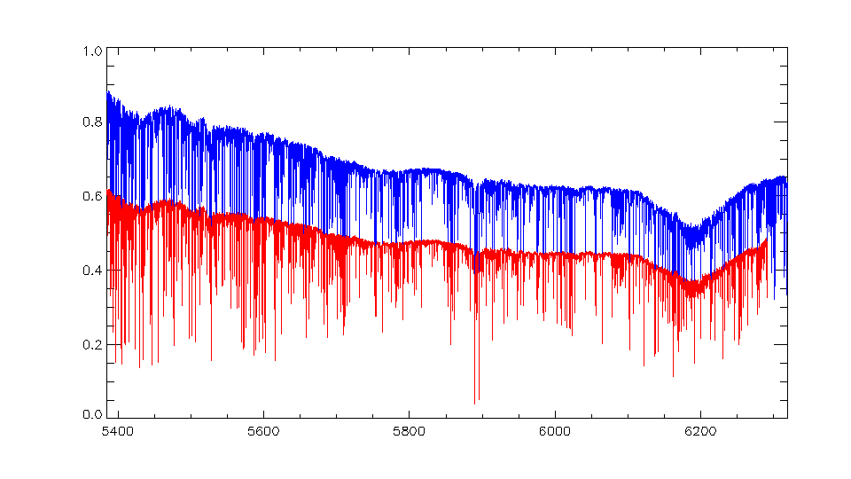

**First Io-in-eclipse spectra: Blue “D” eye, Red = “S” eye. Note the ripple effect due to errors in the order overlap / blaze normalization. Note also how relative brightness between the eyes is not preserved, dropping to S/D~45%.**

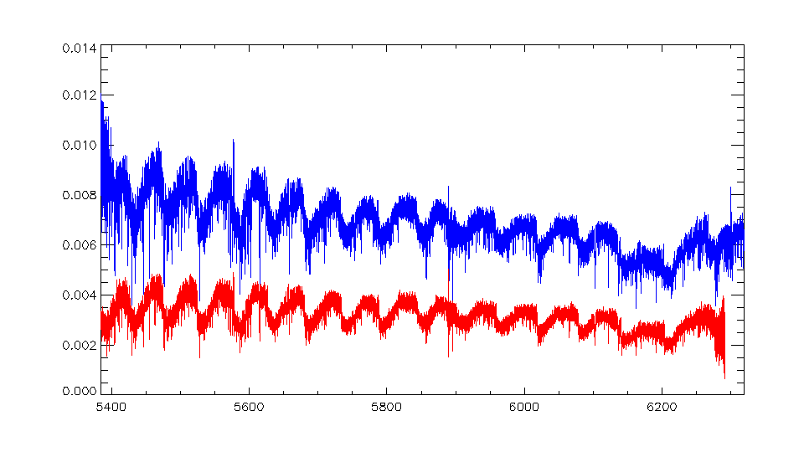

**Last Io-in-eclipse spectra: Blue “D” eye, Red = “S” eye. Note how the order overlap / blaze normalization** **error is gone, presumably since Potsdam’s extraction algorithm can key off the higher count rates. The S/D ratio continues to change however now near ~36%.**

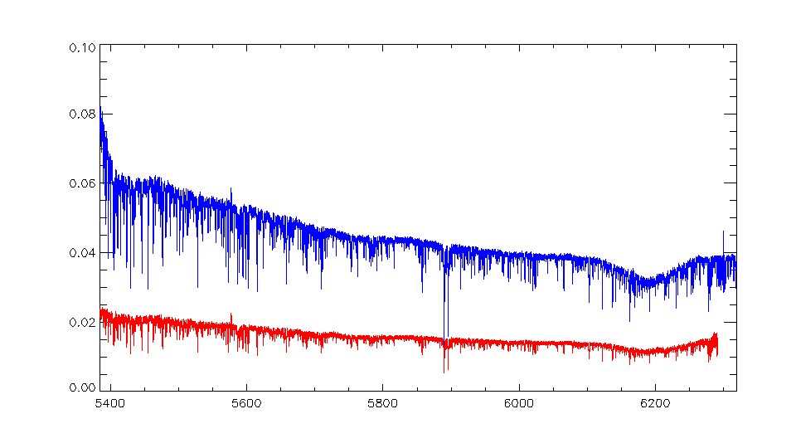

**Perhaps however, that the scattered light of the red S eye is worse however. Thus would produce the same brightness on Io and indeed it does:**

